Women in trades

Interviews with employers and tradeswomen

Produced by the Ministry of Women’s Affairs
November 2011

Purpose
The aim of this study was to understand what employers were currently doing in New Zealand to attract and retain women in male-dominated trades and to learn more about the benefits of having women in what have been traditionally male-dominated industries.
The New Zealand workforce is highly segregated. Around half of all New Zealanders work in occupations in which 70 percent of or more of workers are the same gender as them. A large section of the workforce, approximately 11 percent of all workers, employ virtually no women. These are primarily trades occupations. In 2006, only one percent of builders, plumbers, electricians, and motor mechanics were women.

Occupational segregation contributes to the pay gap between men and women. It may also result in an under-utilisation of women’s and men’s skills, decreased labour mobility, with subsequent negative impacts on economic productivity and economic growth.

There are a number of barriers to women working in trades, including girls not receiving appropriate careers advice, myths and mis-information about gender and trades, lack of flexibility and discrimination.

We wanted to find out from women who are working in trades, and their employers, what works to get women into trades and to support them to remain working in the workplace.

Research approach
We interviewed six employers, selected across a range of industries and across New Zealand. We selected employers that employed women where the occupations were male-dominated (more than 70 percent male) and required a level four qualification or above. The profile of the companies is set out in Table 1 below.
We also interviewed the tradeswomen working at the company. As some companies had more than one woman employed, we interviewed 13 tradeswomen in total. All interviews were conducted at the workplaces of the women.
We have used the information from the interviews to present a case study of each of the organisations. Each case study includes: what the organisation does, how they attracted their women staff, and an understanding of the benefits or the women involved and for the organisations. In the case studies we have used quotes that were directly gained from the interviews and tried to keep the comments, as much as possible, in the voice and style of the participants.

Table 1: Companies we interviewed
Company | Industry | Location | Comment
Women in White Decorators | Painting | Wellington | An all women painting company
Hutt Gas and Plumbing Ltd | Plumbing | Wellington | The plumbing trade is very male-dominated – women make up only 1 percent of plumbers (census 2006).
Unitec Apprenticeship Training Trust | Building | Auckland | The building trade is very male-dominated – women make up only 1 percent of builders (census 2006).
Baytex Manufacturing Co Ltd | Industrial canvas fabrication | Mt Maunganui | Manufacturing is a growth industry in New Zealand (AUT, 2010). There are skills shortages in the motor trades.
Longveld Engineering Ltd | Engineering (welding, fitting and turning) | Hamilton | Light engineering and manufacturing is a growth industry in New Zealand (AUT, 2010)
Electrical Training Company (etco) | Electrical | Auckland | The electrical trade is very male-dominated – women make up only one percent of electricians (census 2006).

Benefits of women in trades
Our research showed that by having more women in their companies, there were strong benefits for the employers, other employees and the women themselves.
A clear message from those interviewed was that employing women increased the value of the services being provided by the company. For many of the companies, having a tradeswomen was a distinct competitive advantage, both from the specific skills that the women brought to their roles, and their approach to customer service.
The key benefits that emerged for employers were the following:
- Women working in a male-dominated industry mellowed the culture and benefitted the workplace
- Employing women employed gave their business a competitive advantage
- Women brought different skills to the roles, for example, excellent attention to detail and good customer service.
The key benefits that emerged for the women employed by these organisations were the following:
- Women felt pride in working with their hands and felt a sense of achievement from their work.
- Many women obserevd that, on the whole, trades workplaces had changed, and more diversity was welcomed. Trade workplaces were not the common stereotype of chauvinistic places with girly calendars (although these places do exist).
- Women enjoyed the benefits of earning while they learnt (i.e they didn’t require a student loan)
- Women developed best in their roles when they had a supportive employer.
Many of the women who were working in the industry, and enjoying success in their jobs attributed this most to women who were in management/decision-making roles within the company. Most women we interviewed had not experienced any barriers to working in a male-dominated trade, although some had experienced difficulty finding an employer who would offer them an apprenticeship. The women also commonly expressed that the reason they believed women did not work in trades was that they were not provided the information that this was a career option.
An opinion commonly expressed by both tradeswomen and employers in the interviews was that trades had evolved. While heavy lifting and hard manual work was still a feature of some workplaces, the consensus was that health and safety requirements meant that the physical requirements of the job were manageable for women.
We are very grateful to the women and their employers who were interviewed for this project for sharing their stories and experiences. Their insights will useful for further work on attracting and retaining women into trades, and helping to break down occupational segregation. The evidence is clear that women can bring many advantages to trades organisations, while offerring them a great employment opportunity.
Women in White Decorators – and Clare
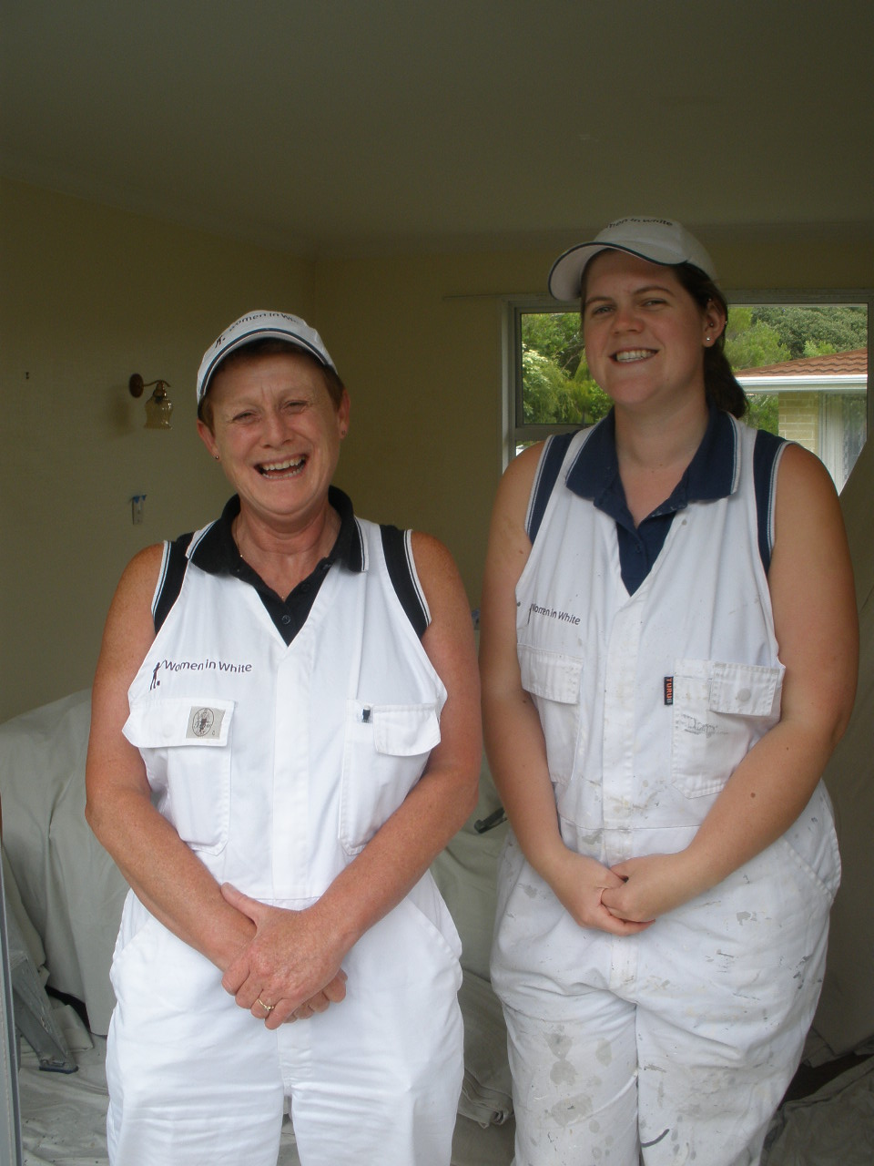Women in White Decorators is a female owned and operated painting and decorating business, based in Wellington. Caroline Robinson has been a painter and decorator for 25 years and created Women in White in 2006.
Women in White are known as the ‘invisible painters’ – they pride themselves on great customer service and a high standard of work.
We interviewed Caroline and Clare Dunkerley – who is now a fully qualified painter and decorator after doing a three-year apprenticeship.

What are the benefits of an all women painting company?
Caroline believes the greatest benefit of female painters is their ability to meet the customer’s needs:
“The customers appreciate the things that women do such as tidiness, attention to detail. We always quality check at the end of a job – so we leave the house and walk back in pretending to be the customer – do it once and do it right.”
Other benefits include:
- providing unique points of difference for the business
- customers often feeling more comfortable with female decorators – particularly female and elderly customers
- doing a top quality job for customers.
Caroline suggested that the ‘niche’ market enabled Women in White to get through the recession. While other painting companies have struggled over the past couple of years, Women in White have repeat customers that have kept the work flow constant.

The benefits of being a tradeswoman
Clare believes that being a tradeswoman provides good job satisfaction – you can see the end result. She also appreciates the portability of being a painter – “it’s the same everywhere”, so provides an opportunity to travel and work.

What works to attract and retain women in trades?
Clare would like it if there were more women working as painters. She believes women lack information and, as a result, do not even consider a trades career. Clare believes that teachers and careers advisors should be providing more information to women. She also believes that employers could do more to attract women – “advertise better, and create suitable working conditions that women want to work in”.
Caroline says that Women in White’s advertising highlights the fact it is a woman run company – and that attracts women who want to work for the company. Caroline also actively seeks female trainees through the local polytechnic.
Caroline believes communication with staff and providing an on-going challenge is what helps keep women working in the trade. This involves:
- listening to what staff want – ‘You find you’re a counsellor as well as an employer’.
- seeing what they can achieve and believing they can do it.
Caroline’s goal is to have more women working as painters, and perhaps to branch out to have an all women home renovation company.
“Women have a ‘can do’ attitude. ‘I never did this for money; I did it to get women out there’. My dream is to see more women in painting.”
Hutt Gas and Plumbing Ltd – and Shelley
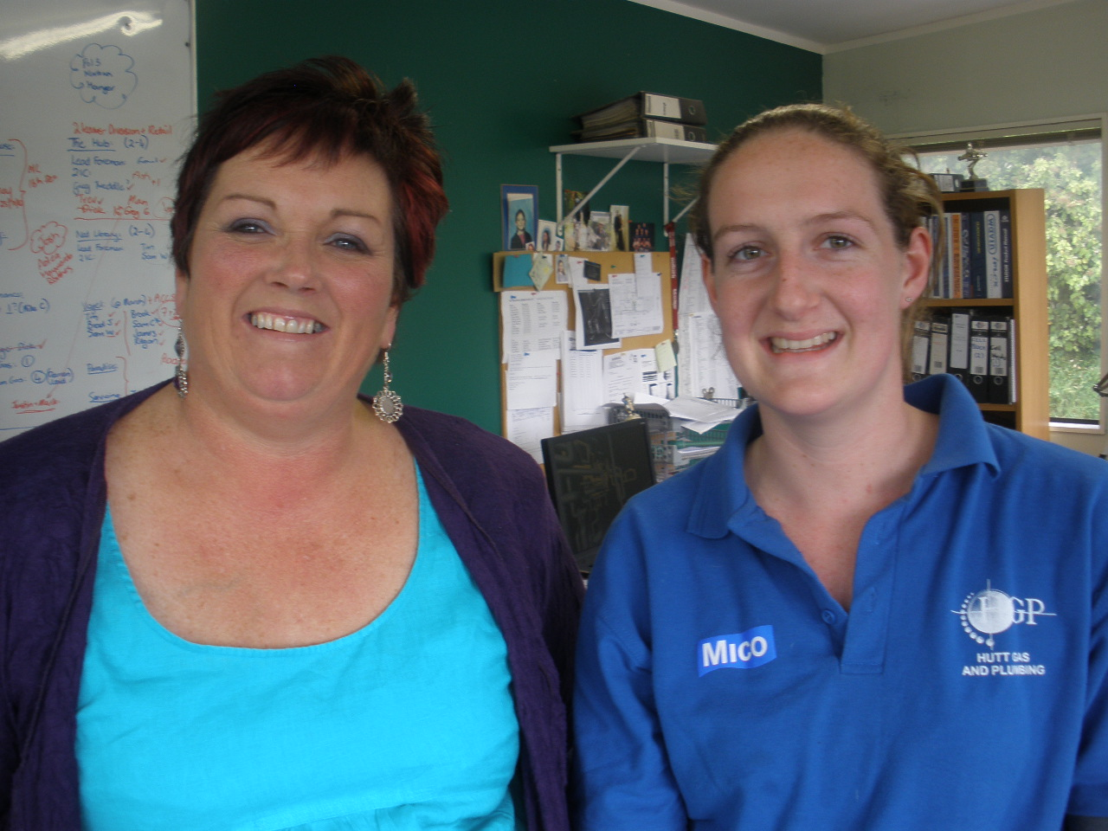Hutt Gas specialises mainly in commercial gas fitting and plumbing work. Hutt Gas has been operating in the Wellington region for 15 years and employs 26 staff.
Aside from the three owners and two women in the office, all other employees are plumbers and gasfitters (including eight apprentices).
We interviewed Colleen Upton (part owner) and Shelley (plumber and gasfitter). Shelley started as an apprentice five years ago and completed her apprenticeship within three years. She is the only female plumber at Hutt Gas.
Shelley featured on Campbell Live about two years ago in a feature about her being a plumber by day and a ballroom dancer by night.
What are the benefits of having a female plumber in the company?
Colleen highlighted numerous benefits of having Shelley working for the company – most centre on customer service and this has many business benefits. Colleen said:
“We market that we have a woman. Shelley is sympathetic to customers. When she’s in someone’s home, Shelley takes extra care – for example, a customer rang up and said she’s found Shelley sitting at her dining table...Shelley was checking to see that the placement of the heater ensured you couldn’t see the cords etc while sitting down for dinner – the boys would never think of that.”
“If Shelley is working on a hot water tank she always puts the towels back, whereas the boys leave them to the side. Sometimes we hear funny stories from customers who’ve had calls from concerned neighbours saying ‘you’ve got a girl playing with your Toby’.”
Colleen says the best things about having a female plumber are:
- feedback from customers that they have had better service than expected
- attention to detail (especially in domestic work)
- female customers feel safer
- Shelley goes the extra mile to make sure the customers are happy
- the boys probably behave a bit better.
Colleen commented that employers can’t use the excuse of women not being able to cope with the physical demands of the job, because “no one’s supposed to be lifting more than 20 kg anyway”.

The benefits of being a tradeswoman
Shelley values the fact she is treated like any other plumber on the team: “I don’t want to get any special treatment”.
Shelley doesn’t mind working in a male-dominated occupation, she thinks that basically men and women are not that different – “men gossip just as much, if not more”. She says that while there can be awkward moments when she starts a new job “once they warm to you it can be really fun”.
In her time at Hutt Gas, Shelley has launched ahead in her career – which started with a keen commitment to getting her apprenticeship paper work completed early:
“I’ve been here 5 years, have my own van, and train apprentices. I am more motivated than some of the others so I get ahead”.
There are also some less serious and more light-hearted aspects of the job that Shelley enjoys:
“There are a lot of terms in the trade with inappropriate connotations e.g. ball cocks. So sometimes we have a lot of laughs when I have to ask the guys things like ‘can I grab your nuts?’, or, ‘I’m looking for a penetration’.”
It took a lot of perseverance from Shelley to get an apprenticeship:
“There was a lot in the media about plumbing shortages so I said to Dad ‘I might be a plumber’. Dad set me up with some work experience. I approached most of the employers in the Wellington region – around 30 – I only heard from one who said they had no vacancies. So I went to Weltec to do the pre-trades plumbing course and Weltec spoke to Colleen about me and she agreed to take me on.”
“Mum said I ‘was born to be a plumber’ because I was born with a ventouse – which is just like a plunger.”
Shelley’s top three benefits of being a tradeswomen are:
- lots of career prospects, for example moving into management
- earning straight away – no student loan
- as a woman ‘you do get pretty famous’ – people remember you so that’s good for business.

What works to attract and retain women in trades?
Shelley’s advice to other women considering a trade is:
“If girls are looking to do a trade you have to fit in to the culture – it’s been around for a long time and you can’t expect to change it e.g. rude pictures. Sometimes you might get a crude comment but you just ignore it and it goes away.”
Shelley also reflects on her positive financial position, which may help others to consider trades as a career:
“Girls still think of it as a job that girls don’t do but I’m in a good position – with a house already and no student loan – also getting paid more than my friends who went to university.”
Colleen says flexibility is the key to ensuring valued tradeswomen stay on board. Shelley’s five-year commitment to Hutt Gas is testament to that.
“Shelley talks about having kids one day. Some work e.g. climbing ladders won’t suit her during pregnancy. Shelley excels in domestic work. We’ve started training her in specialist appliance servicing because she could carry this on during pregnancy. We can tailor trades work to suit her availability after returns to work.”
Colleen felt that schools were not doing enough to encourage any students into a trade, let alone girls. She says “we do careers evenings at high schools but there is a lack of interest from college students. These days everyone wants to be a lawyer or a doctor”.
The work environment has to be suitable – and this benefits everybody. Hutt Gas has clear policies on harassment and guidelines on health and safety:

Message to employers who might consider taking on tradeswomen
‘It’s a great marketing tool for your company. They can do the job.”

Longveld Engineering Ltd – and Cassie, Lianne, Huiroa, Debbie and Mamai
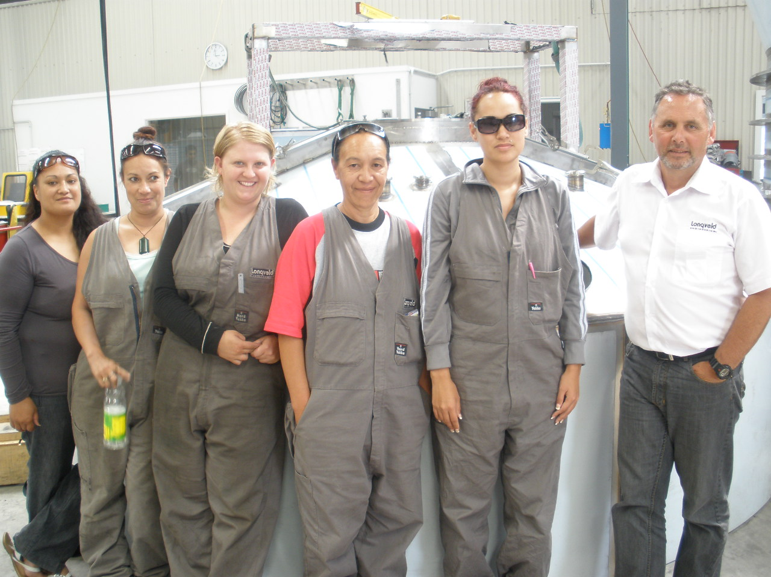Longveld Engineering Ltd is a stainless steel fabrication specialist located in Hamilton. It provides services in a range of industries including dairy, pharmaceutical, telecommunications, transport, energy, air conditioning and plumbing.

The company was started in 1992, and now has 80 staff – 70 of whom are trade staff. Longveld usually have between five and eight apprentices. The company currently has one female apprentice – Cassie, who is an apprentice fitter and turner – a trade that is 99 percent male-dominated.

In August 2010, Longveld launched ‘Women in Welding’; a partnership with the Ministry of Social Development and Competenz (the Engineering Industry Training Organisation), to provide welding trade training and employment for Work and Income clients (in this case, DPB clients). Longveld has employed four women as trainee production welders under this scheme.

We interviewed Les Roa, the managing director, Cassie (apprentice fitter and turner), Lianne, Huiroa, Debbie and Mamai (trainee welders). We also received input from Pam Roa, the executive director of Longveld.

The benefits of having tradeswomen working in the company
Les says having tradeswomen working for the company fits with the Longveld culture – which promotes diversity and respect as a matter of course. He says the top three benefits are:
- mellowing of ‘gung-ho’ male attitude
- providing a competitive advantage
- improving communication skills
Les believes that “having a gender-diverse workforce takes the blokiness out of the workplace”.
Les says that there are economic as well as social benefits.
“Yes it’s also about social responsibility, but there are economic benefits as well. Diversity in our workforce improves productivity and customer satisfaction.”
Pam considers having women in the business has made Longveld a ‘more balanced and diverse workplace’. Pam also says that “the women we have show a fine eye for detail which suits our unique selling point”.

The benefits of being a tradeswoman
Cassie says the best thing about her job is the challenge: “actually having to use my brain, my mind and it’s physically challenging too”. She sets her sights high and aims to:
‘Work up the ladder. Finish my apprenticeship, then complete a business management course – eventually run my own business.”
Mamai, a trainee welder, values the skills she is gaining and the flexible hours Longveld offers: “We’ve got the skills [and] we’re home before the kids are”.
Debbie, another trainee welder appreciates the opportunity Longveld has given her: “Getting off the benefit - you know you’re going to end up somewhere”.
The Women in Welding team identified the top three benefits of working as tradeswomen for Longveld as pay, the family centred workplace of Longveld, and the atmosphere and sense of pride of working in a factory.

What works to attract and retain women in trades?
Cassie noticed the difference in attitude towards tradeswomen - between Longveld and other employers: “I’ve been to so many places and been turned down and Longveld are screaming out for women”.
Cassie says her ‘can do’ attitude helped get her through the door:
“It all depends on your attitude – sometimes you can be knocked down – but be persistent.”
“I was kind of pushed into the first job by a friend. ‘I thought, if I don’t get it I’m in the same place I was but if I do, it’s great’”.
Les says that business exposure attracts more women. Longveld also targeted a pool of people who want to work – be off the benefit (Women in Welding). Longveld also targets female students:
“We have held a 'Young Women in Engineering' event where girls from colleges such as Hamilton Girls come and see us and consider a career [in engineering’”.
The culture of diversity and respect works for everybody, not just women, says Les:
“We have a safe, nurturing environment. Our culture creates a pleasant place to work for a diverse range of people.”
“The general environment has to be conducive to anyone to stay. There are opportunities for job sharing, pooling resources for childcare - making it even more flexible.”
Pam says that the company believes that “a diverse workplace is a healthy workplace”. Pam and Les want Longveld to be “representative of the world we live in, and we enjoy the challenge of making that happen”. As part of its diversity strategy, Longveld have an objective that, by 2015, its trades staff will comprise 20 percent women.
“One strategic objective is to have 20 percent of the workforce as women. The Women in Welding group came about when we came up with a plan and approached WINZ and MSD to see if it rang bells for them.”
Pam believes that having a group of women working together (as in the Women in Welding initiative) has ensured a level of support for each of the women. This has made it easier for those women who are less confident, and means they are more likely to stay.

What will work to get other employers taking on tradeswomen?
Les believes by promoting the economic benefits, other employers will start to see the benefits of employing tradeswomen:
“We have a high profile with our business awards - we know that other employers are watching us and so we constantly push the importance of training female tradespeople.”

Message to employers who might consider taking on tradeswomen
“You get a huge amount of joy seeing people grow and blossom.” (Les)
“It’s competitive advantage, it’s financially beneficial and it feels great to do it.” (Les)
“Stop being so segregated, so sexist. There’s a real opportunity for others to see that there are ladies out there who can do it.” (Cassie)
“Look after your workers and you’ll get more out of them.” (Lianne)

The Electrical Training Company– and Bernadette and Alicia

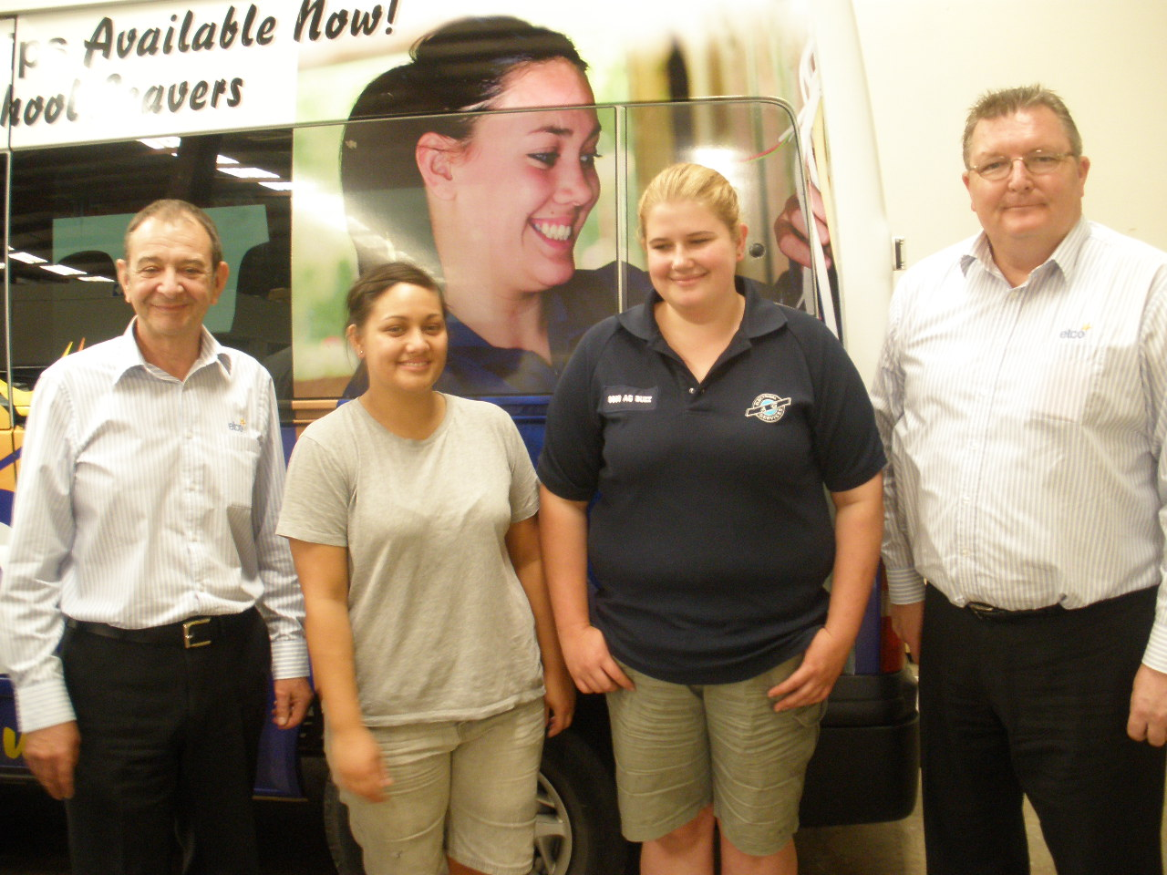The Electrical Training Company (etco) employs electrical apprentices who are training towards a National Certificate in Electrical Engineering (level 4), and places them with host companies for on-the-job training. Nationwide there are 10 branches of etco, some with full training facilities (for example, Auckland).

In 2011, 240 new apprentices are required – taking the total to 560. Etco has 13 female apprentices across the country – this equates to four percent women, which is higher than the one percent of women in the trade nationally (2006 census).

We interviewed Peter Rushworth (chief executive officer) and John Riley (apprenticeship manager), and two female apprentices, Bernadette Dolan and Alicia Blom. Both apprentices have been with etco for over a year.
Both Alicia and Bernadette did most of their paperwork at Manukau Institute of Technology, and contacted etco for support in finding an apprenticeship with different employers.

The benefits of having tradeswomen working in the company
Peter says he would like more women if he could find them: “With 240 to employ this year we need just about everybody we can get”. This is because, he says:
“I think young women make good apprentice electricians - they are hardworking, they clean up, and language has improved on site and in training.”
John commented that being a woman (in addition to skills) can be a benefit in itself – particularly when there are women on site, for example in domestic work:
“Skycity needed work on its female locker room so they wanted a female electrician.”
“Auckland airport appreciated having a female electrician because there were mainly women in the office.”
John and Peter talked about the kind of attitude required for working in a trade:
“You’ve not necessarily got to be one of the boys but you can’t be too thin-skinned neither.”
“One of our women was asked how would she would deal with all the swearing on a big job – and she replied ‘that’s OK, I promise not to swear!”
Focus and determination are the most beneficial attributes, they say.

Benefits of being a tradeswoman
Alicia appreciates that people on site show ‘a little more respect’ for her.
Bernadette adds that “if you get given grief, just give it back”.
Alicia says that women are still uncommon on site and she recalls a time when this became particularly obvious:
“Once I was up a ladder with my top half in the ceiling – and someone came in and said ‘hey bro’!”
The practical and useful nature of the job is something that Alicia and Bernadette find beneficial:
“I like completing something and seeing it works.”
“Having the knowledge to fix appliances in your own home. You are independent and you can do stuff without electrocuting yourself!”
Doing a job that is a bit different has its benefits:
“Seeing the shock on people’s faces when you tell them you’re an electrician apprentice – they’re like ‘wow’!” Alicia
“There’s a lot of good humour - you can make some good friends. It’s cool to be an electrician.” Bernadette

What works to attract and retain women in trades?
Bernadette thinks that aspiring tradeswomen need to have the right mindset:
“Society has made it seem like it’s not a viable option - it’s possible, you just need to have the right mindset.”
Bernadette believes targeting female students is the way to go:
“I think you need to start earlier at high schools, having a chick on site at careers expos would be good - it’s nice to meet someone in the trade.”
Bernadette also highlights the career prospects that the trades offer:
“I’ve completed a degree in business and information management so one day I hope to put it all together (by getting into management).”
John and Peter believe that profiling real women in the trades is a good way to attract more women:
“It is important to profile women in trades. Chloe is one of our apprentices and she features in our etco promotional material and in Electrolink (trades magazine). We also attend careers expos. We want women because of their technical ability, logical thinking, methodological way of working, customer service and it’s less physical than other trades.”
John and Peter reflected on the first women to join etco:
“Our first women were recruited in the 1980s - ‘any barriers I had, [the women] broke down. We’ve always had women.”
“Why would we not want to encourage women?” John
The apprentices are supported throughout their training and they have the opportunity to work for multiple employers over the course of their apprenticeship. Co-ordinators are responsible for the apprentices (they have about 50 apprentices each) and it is their role is to take them through to completion.
John and Peter comment that parental leave and part-time work is possible: ‘The recession has made us more flexible than ever before – as long as we can find a host’.
John and Peter suggest that Electrolink magazine would be a good way to get other employers to consider employing women. Electrolink is the magazine of choice for employers.
Etco also has a ‘Why you should become a host company pamphlet’ to attract employers to take on women. It profiles other women who are already in the trade and promotes that:
“‘Women make great electricians – and win apprentice of the year as much as the men.”
John also thinks that women are naturally getting into trades and that the new younger generation of tradesmen “have just got used to it” and this will slowly take over the traditional male attitudes that used to predominate.
Baytex Manufacturing Co Ltd – and Katie, Aurora, and Chanel
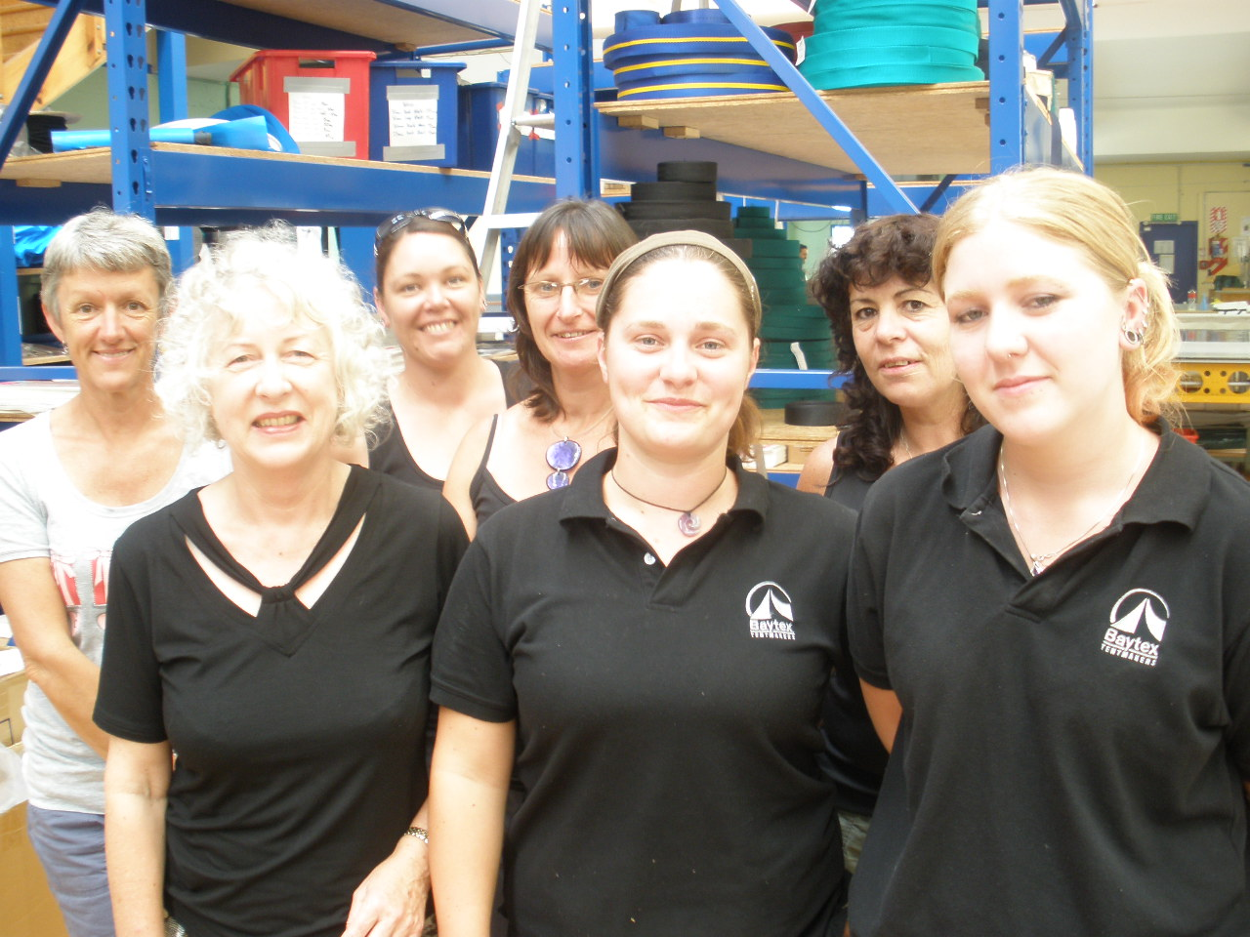Baytex is a marquee manufacturing business and was established in 1969.
Baytex exports over 50 percent of its work, which includes large scale architecturally designed PVC structures.
Baytex has over 40 staff at its companies in Tauranga, Australia and in the United States. Baytex is associated with MITO and it employs tradespeople in the canvas fabrication, engineering and industrial sewing trades.
Baytex has two qualified female canvas fabricators and one apprentice. Canvas fabricating is a specialist trade, with only around 50 new apprentices each year. Baytex also has eight senior sewing machinists.
We interviewed Wendy Tankard (company director), Louise Pike (textile fabricator), Julie Clifton (supervisor and senior sewing machinist), Jill Bennie (assistant supervisor and senior sewing machinist), Katie Wiseman (supervisor and tradesperson canvas fabricator), Aurora Jordan (apprentice canvas fabricator) and Chanel Davies (tradesperson canvas fabricator).
Katie started at Baytex at age 16 as a sewing machinist. She completed her apprenticeship in canvas fabrication in 2006, and has worked her way up to supervisor of the marquee floor, which involves managing ten staff. Katie won Tier 1 and 2 Apprentice of the Year. She is the first female and the youngest ever supervisor at Baytex.
Aurora has been at Baytex for almost four years and as an apprentice canvas fabricator for the past two years. Aurora was awarded Tier 1 Apprentice of the Year 2010.
Chanel has worked at Baytex since 2000 as a canvas fabricator. Chanel was awarded Tier One Apprentice of the Year in 2001. She has been on parental leave twice and currently works part-time (15 hours).

The benefits of having tradeswomen in the company
Wendy, after 15 years of hard work to get women on the marquee floor noticed that:
“As soon as I put the women out there, the men had to work smarter and harder like the women.”
In addition, Wendy appreciates the following benefits of having women working at Baytex
- the change in men’s attitudes to women
- men had to smarten their act – dress, swearing, and work ethic
- reduces injury rates – working smarter not harder
- the attitude to winning is better
- helped to balance the business
- women achieve their paper work more efficiently
- women have high levels of knowledge and are strong psychologically – in order to get respect from men.

The benefits of being a tradeswoman
All of the tradeswomen commented on the sense of achievement that working in the trades brings, including:
- pay, knowledge and variety – the wow factor of the work, are the best things about the job (Louise)
- variety, people we work with/working conditions, pay and talent recognition are the best things about the job (Julie and Jill)
- keeping fit, seeing the finished product, people/social aspect and accommodating my needs when I was pregnant, are the things she appreciates most (Chanel)
- the rewarding job, sense of achievement, work environment/team, are the best things about the job (Katie)
- having a trade behind you, good experience, range of work, are the top things about her job (Aurora).
At Baytex, the women are successful at the jobs they do:
“Trying extra hard and we get respect for that – none of the males have won Apprentice of the Year and all three women have.” Katie
“There are guys there if we need them, but we can pretty much handle anything.” Katie
The opportunities for challenge and to utilise their skills are obvious:
“Once I’ve finished my apprenticeship I can keep learning and it gives me opportunities to go overseas.” Aurora
“People, work environment, rewarding, enjoy the organisational and problem solving aspects of the job.” Katie
“Every time we get a new machine I want to learn to use it.” Louise
“Set up a challenge and they’ll help us achieve it.” Louise

What works to attract and retain women in trades?
Wendy says that challenge and training are central to keeping women engaged. The specific things that Wendy does are:
- offer promotions – new and different roles
- training – as much as they’ll take, for example literacy and computer skills and supervisory training
- offer apprenticeships (many of the women started as sewers and moved into canvas fabrication, and were then offered apprenticeships)
- encourage awards – three women have been put forward and all have taken tier 1 or tier 2 Apprentice of the Year
- lots of praise and encouragement
- clean, organised and tidy facilities.
Women identified role-modelling of women already in the trades as an important way to attract others:
“Katie won apprentice of the year twice in a row. If she can do it then I can do it.” Aurora
“Getting out to the schools – role-modelling women already in trades.” Wendy
The tradeswomen at Baytex also commented that if it wasn’t for Wendy, there wouldn’t be as many women working there, and they probably wouldn’t be in the positions that they are.
Promoting trades in a way that works for young women is also important, such as via careers advisors and modern technology:
“To attract women – twitter, facebook, text.” Wendy
“Career Advisors – give them more information about getting women into trades.” Louise
“Present it at schools in a way that attracts women – so they think of doing it.” Katie
“Word of mouth is most important. MITO did a DVD on Baytex for Just the Job. Advertising through schools by giving information to careers advisors.” Wendy
“Promoting trades – lots of people don’t know about it – or think ‘it’s not the job for me – too heavy.” Chanel

What can other employers do to get women working in trades?
More women at the top, like Wendy, to encourage workplaces to take on tradeswomen are required:
“Need more women at the top to encourage women tradies to come on board”. (Wendy)
“Employers realising women can do it. Need more women like Wendy – leadership.” (Julie and Jill)
“Making employers aware that women can do the job. Getting females into the interviews. A website where employers can advertise jobs and welcome/target women” (Katie)
Publicity is also important, via brochures etc and showing what women can do:
“Anyone who has any doubts about me – that won’t last long because they see how well I work.” (Katie)

Unitec Apprenticeship Trust – and Kartika
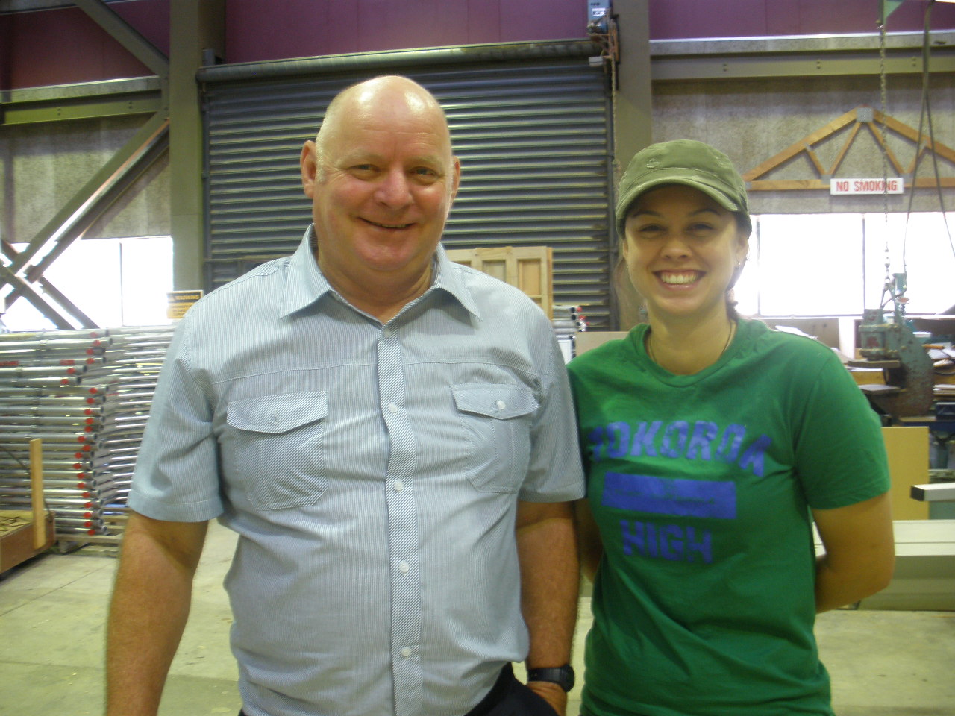The Trust was established in 2004 and is based at Auckland’s Unitec. It has the role of the employer and subcontracts carpentry apprentices to employers. The Trust has 42 apprentices, three of which are women.
“We’re looking for people with the right attitude, to be the best.”
“Punctuality, manners, and presentation – everything is built on these qualities.”
We interviewed Joe Hede (manager) and Kartika Mutzelburg (carpentry apprentice). Kartika is in her fourth year of her carpentry apprenticeship. Kartika won building Apprentice of the Year in 2010. She says of the Trust:
“I approached different builders offering free labour to see what it was like on-site but no-one wanted to take me on so I went to the Trust. If it wasn’t for the Trust, I wouldn’t have any work because no-one took me seriously.”

The benefits of having tradeswomen on board
Joe says that women go the extra mile:
“The women get spoilt for a reason, because they go the extra mile - of course she’s going to be my favourite. Her (Kartika’s) first response to any request is ‘what time do you want me there, Joe.”
The high performance and determination of the women is clear:
“I knew as soon as I met her [Kartika] that we were onto a winner... Dogged determination is what she’s got – she’ll keep going until she’ll get it.”
Joe says the three top business benefits for employing women in trades are their superior performance, attention to detail and improved image of the company.
These benefits improve the Trust’s credibility and have a positive effect on others:
“Kartika’s success has given the Trust more credibility. If you get the right people to do it with you – it’s a great success – hugely rewarding for me – to promote the Apprenticeship Training Trust.”
“Having a female involved, it ups the performance of the guys – e.g. the language drops”.

The benefits of being a tradeswoman
Kartika refutes there are any real barriers to women working in trades:
“There are some things I can’t lift but that is not what it’s all about.”
“Joe makes sure there’s a toilet – on time. You don’t need a woman’s toilet – just a toilet - with toilet paper is fine.”
She says she is in the building trade because she enjoys making something out of nothing:
“I love making things – and saying this is what I’ve done. It’s like a holiday you get paid for – it’s fantastic. It’s creative and other people benefit from it.”
Kartika receives a lot of support from her fellow students and from the Trust:
“Everyone’s eager for me to do well – in class etc. I do get a bit more attention because I’m a girl but it’s always on merit too.”
Her top three things about being a tradeswomen are; she likes being the minority, she feels looked after, and her work looks better ‘because no one expects it to!’
Kartika has high aspirations – beyond being on the tools:
“I want to do property development – and know the ropes first.”
What works to get and keep more women working in trades?
Kartika believes profiling tradeswomen would help encourage other women to take on a trade:
“Unitec has asked me to do talks at careers events – having a woman on the stand would make a difference. Having tradeswomen getting exposure out there so that young people can see they are out there.”
“They’ve put me in the Unitec catalogue to get the face of women out there.”
Joe reflects that Kartika’s success and her profile as the first building apprentice with the Trust has helped attract women. The Trust promotes its tradeswomen in its own magazine and Joe also goes out to talk to schools. He notes the interest from girls at schools and at Unitec:
“I had a lot of enquiries from girls at schools – a lot of questions being asked in the last few years.”
“I go out to the classroom and look at upcomers, attitudes. I approached her and asked if she was interested and she [Kartika] was.”
Importantly, Joe has a passion for making the trade even more attractive to women:
“I’m on a bit of a campaign to break down barriers. I’d want to see it more accessible before I retire.”
Kartika won the Certified Builder’s Apprentice of the Year last year. She was the first ever woman to win the award. According to Joe, “this is definitely confirmation that what we’re doing is on the right track”.

What can other employers do to get women working in trades?
Joe recounts a story that sums up both the challenge of getting a woman in the door and the transformation that can occur:
“Women are a lot more difficult for me to place but once I’m let through the door, I’m right. Once a guy rang up and asked for an apprentice, I said ‘I’ll bring her out this afternoon’. He responded ‘what’s this Sheila business?’ He tried all the excuses. I left them together and after two weeks I wanted Kartika back for Habitat for Humanity and he said ‘You leave the girl here, you take the boy’.”
Joe thinks that traditional employer perceptions towards tradeswomen can be changed:
“I think employers think they have to change too many things, but toilets aren’t an issue. I think some think ‘oh what will happen if I accidentally grabbed her in the wrong place?’ They’re unsure of what to do in certain situations, there’s a bit of embarrassment and a bit of fear they’ll want to come in and tidy up their domain.”
“Things are changing – dodgy calendars and that – that’s about marking their territory.”
He thinks the best ways to change perceptions is to improve general knowledge:
“Showing builders that girls are on site ‘bringing it to the norm’. Publicising it. Get their faces out there in as many publications as possible, newspapers, television. It needs to be timely too – so that other news doesn’t overtake it. Employers need to experience it as well as know the theory behind taking on women.”
Kartika agrees that employers need to know that women can do it:
“One employer didn’t want to subject me to the swearing etc – so he was actually thinking about me. It’s about showing employers that I can hack it.”
“The employers have to want to have women in the trade – ‘why would they want women in trades?’ They need to see a need.”

Statistics New Zealand (2006) New Zealand Census.
Statistics New Zealand (2006) New Zealand Census.

