Free to Lead

Tackling the effects of online harm on the pipeline of future women leaders

Foreword

Long-term insights briefings
Long-term insights briefings (LTIBs) are future-focused documents required under the Public Service Act 2020. LTIBs are not government policy, are independent of ministers, and provide the opportunity to explore and better understand critical issues affecting New Zealand’s future. All government departments are required to produce an LTIB every three years. This round of LTIBs is due by 7 August 2026.
As at March 2026, the Public Service Amendment Bill will shortly have its third reading. If this Bill passes, individual departments will no longer be required to produce LTIBs. Instead, there will be a single LTIB co-ordinated by the Department of Prime Minister and Cabinet.
We are still able to publish this LTIB after the Amendment Bill passes.
We hope this document will inform discussions and decisions, to help make a better future for women in leadership.

Consultation
Under the Public Service Act 2020, we are required to consult with the public twice as part of the development of the briefing – firstly on the proposed topic, and secondly on the content. This is the second round of consultation.

First consultation: Public consultation supported our proposed topic
For the first consultation, in late 2024 and early 2025, the Ministry for Women conducted an online survey and held online meetings. We are very grateful to everyone who took the time to share their views.
Consultation showed overwhelming support for the LTIB topic. Most respondents strongly agreed that online harm was a growing and significant issue impacting the pipeline of future women leaders. Information on the survey respondents and other engagements is in Appendix One.

Hearing the views of young people
After we completed consultation on the topic, the Ministry worked with Koi Tū Centre for Informed Futures to hold workshops to explore young people’s perspectives on online harm and the future of leadership. These workshops ran from July to August 2025, and we received Koi Tū’s report in October 2025.
Participants were mostly young women and girls, aged 16-25, though some people identifying as other genders attended. We are grateful to the young people for sharing their views, and for the organisations that helped us to convene them. The views of these young people are reflected throughout this document.

Research and engagement
The insights in this report have been informed by this consultation, and engagement with government organisations including the Classification Office and the Ministry of Justice; non-government organisations, women’s networks, independent agencies, research groups working on online safety or women’s leadership; and focus groups of young women. These groups and organisations are listed in Appendix One. We also reviewed New Zealand-based research to understand the drivers and impacts of online harm against women leaders here, and international data and evidence that explores broader international trends.

We want to hear your views
As required by the Public Service Act 2020, we are now undertaking public consultation on the draft LTIB.
We want to learn from people – especially those affected by, or working in the field of, online harm – whether this briefing reflects what you know from your experience and expertise.
Please either fill out the submission form or email your feedback to korero@women.govt.nz by Thursday 9 April 2026.
We will take your feedback into account when developing the final version of the LTIB.

Introduction: Online harm has real-life effects on the future of women in leadership
Violence isn’t just harming someone with physical force. It can also include non-physical acts that verbally, emotionally, or financially harm someone.
Online harm is using information and communication technology (mobile phones, the Internet, social media, and video games) to abuse, harass, intimidate or denigrate someone.
While online harm is not new, rapid growth in the use of social media and other information communication technologies (ICTs) has intensified existing forms of harm, like harassment, abuse and hate speech. It has also created the environment for new forms of harm, like image-based abuse and doxing (sharing personal information without consent).
ICTs, and related technologies like artificial intelligence, are constantly changing. We can expect new forms of harm, and variations on existing forms, to keep arising. Internationally, governments, communities, and ICT companies, constantly face new challenges in preventing and responding to these harms.
Online harm includes:
- cyber-bullying, cyberstalking, harassment, trolling and abuse
- image based sexual abuse, including deep fakes and “sextortion” (threatening to share images unless demands are met)
- false allegations
- doxxing
- threats of violence, including rape and death threats
- hate speech and mis/disinformation aiming to undermine an individual or group.
Perpetrators of online harm may target a specific person or group, but its impact can often be felt more widely, across communities and demographic groups. For example, seeing women denigrated online can normalise misogyny, and can drive women away from online spaces.

Women in leadership are experiencing increasing online harm
Online harm can affect anyone, but we are focusing on women in leadership.
The causes and effects of online harm on current and emerging women leaders, remain under-researched in New Zealand. We know that current data captures only the tip of the iceberg, as many cases of online harm against women go unreported due to stigma, shame, fear of retaliation, or unclear reporting options. There are also significant data gaps about the frequency, drivers and impacts of online harm on women in leadership.

Women leaders experience distinct types of online harm compared with men
Online harm against women is often more personal and more threatening. Research shows online harm against women in leadership is increasing.
Online harm can:
- affect women’s sense of safety, privacy, and security
- mean women change how they use online spaces, or stop using them altogether
- impact women’s careers and affect participation in democracy and leadership.
“As a woman in business, I have faced a barrage of online attacks online. You go into defensive mode, feel misunderstood… I experienced threats and it was affecting my child. My IP address was located. I nearly withdrew [from] my whole business due to the impact.” Business owner
When young people see online harm against women, and when young women experience it, it can:
- normalise the behaviour, affecting how girls are treated on and offline
- cause young women to withdraw from online life, and become isolated
- discourage girls from pursuing leadership roles.
“You don’t want to see yourself as a leader if you see that all female leaders who are out there are getting these vicious takedowns” Young woman
Over time, we may see more women leave public and leadership roles, and fewer girls willing or able to enter public life. Because wāhine Māori, Pacific, ethnic, disabled, and rainbow women, are targeted more than others, we may see less diversity among the women who take on leadership roles. With fewer women at decision-making tables, we could see women’s rights, or social or economic position in society go backwards.

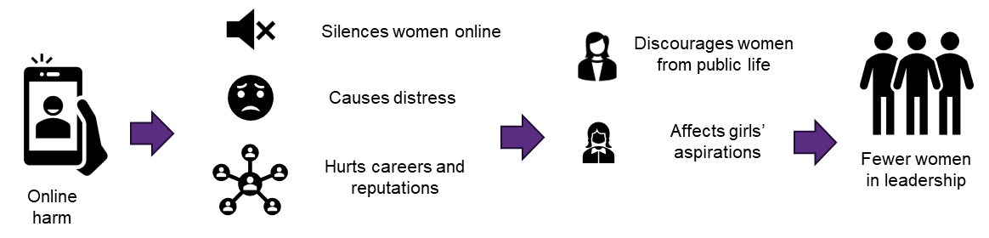

Things could change for the better
There are worrying signs about where we might be headed, but it’s not inevitable.
We hope this document will inform discussions and decisions, to help make a better future for women in leadership.

What the data says
Most of the research we found is based on reporting of harm, surveys and qualitative interviews. Online harm is underreported for reasons including fear of retaliation, not knowing how to report incidents, a lack of awareness of what should be reported, or a lack of trust in reporting channels.
What we do know shows suggests online harm is a significant problem here and overseas, particularly for women. For example:
- From February 2022 to July 2024, Netsafe received 33,530 reports of online harm where the gender of the victim was specified. 56.3% of victims were women.
- In the 2025 Gender Attitudes Survey, 74% of New Zealanders agreed online harassment is a serious problem, and 71% agreed that online harassment affects women in “real” (offline) life.
- In 2023, a Centre for International Governance Innovation (CIGI) study found 60% of women across 18 countries had experienced at least one form of online harm.

Some groups experience more online harm
- Netsafe’s 2025 Online Hate Speech report found those under age 30, Māori, and LGBTQIA+ community members are more likely than average to experience hate speech. Hate speech relating to ethnicity has grown steadily since 2018 and is the most widely experienced hate speech.
- New Zealand’s 2024 Internet insights show disabled New Zealanders are more likely to experience online harm or harassment (26% compared to an average of 16%).

- A 2021 US study found lesbian, gay or bisexual online harassment targets are more likely to report having encountered harassment online because of their gender (54%) compared with their straight counterparts (31%).
“I have received messages in Instagram through news articles in the comments section, that sort of thing, that are really derogatory and quite harmful, and generally speaking they tend to be related to my sexuality.” – Actor, comedian, and educator Karen O’Leary
- The CIGI study found transgender and gender diverse people are more likely to report incidents of online harm
- Young women report more experiences of online harm, especially those who speak out on issues they care about as well as young women in politics.
  - The 2020 State of the World’s Girls report found that 58% of girls and young women experienced online harassment; girls who spoke about political issues like race, feminism and human rights experienced more online harm.
  - A 2018 New Zealand study found 19% of secondary school girls felt online harm was affecting their daily lives, including their ability to study and go to school.
- High-profile women are often targets. A 2022 global survey of women journalists found that 73% had experienced online violence in their career. A quarter had received threats of physical violence, including death threats.
“Have I been silenced over the years, absolutely. Have I taken absolute care to not be seen unnecessarily? 100 percent. And how dare they.” – Actress, broadcaster, writer, and producer, Teuila Blakely
Appendix Two has more information about the kinds of online harm women in leadership may experience.

Elected leaders are targeted
- A 2025 study of 85 women parliamentarians in the Asia-Pacific region found 60% experienced online harm, with over one-third receiving threats.
New Zealand women MPs experience more personal, sexual and violent abuse
- A survey of New Zealand members of parliament found, 96% experience inappropriate social media contact in 2022, compared to 60% in 2014. .
- Women were at significantly higher risk of gendered abuse, sexualised comments, and threats of death, sexual violence, or towards their family.

Table 1: Types of abuse experienced by New Zealand MPs
Type of abuse | Female | Male
Abuse on political grounds | 81% | 95%
Gendered abuse | 63% | 25%
COVID-19 related abuse | 63% | 50%
Threats of physical abuse | 47% | 30%
Threats of reputational damage | 47% | 50%
Sexualised comments | 41% | 10%
Death threats | 34% | 15%
Racial Abuse | 33% | 25%
Threats to family | 28% | 5%
Threats of sexual violence | 22% | 0%
Sexual orientation abuse | 16% | 5%
Threats to staff | 16% | 5%
Abuse on religious grounds | 16% | 20%

46% of the female MPs (compared to 5% of male) felt unsafe in their own homes.
In 2025, researchers interviewed eleven female New Zealand members of parliament about their experiences of harassment, including online harm. They found that:
- misogyny and racism were ubiquitous in the harassment of female MPs, their staff, and their families: ‘[I would] probably not [become an MP with hindsight]. … I mean it's been incredible intrusion on my personal life, incredible intrusion on my family.’ -Member of Parliament
- responding to abuse came at great personal cost, including increased mental and administrative workloads
- impacts of harassment were considerable. Some MPs experienced flashbacks and suicidality.
‘to suddenly have like, misogyny and racism in NZ crystallised for you so personally, every second of the day, because it's relentless–there's not a break from it. There's not a single post that I've [posted] that doesn't have, like misogynistic comments or racist comments on it. … And then you add to it that like death threats and whatever, and no one, no one prepares you for that.’ -Member of Parliament
Wāhine Māori are often targeted
- In the lead up to the 2023 General Election, high-profile wāhine Māori experienced:
- threats of violence, sexual violence, and death
- misogynistic harassment about their actions and appearance
- offline instances of violence and stalking of wāhine Māori politicians
- targeted harassment aimed at specific individuals
- instigation of violence against wāhine Māori, on Twitter/X.
“Māori and Pasifika women in our country are probably the most targeted group online. And I feel like I can say that so confidently.” – Radio personality Lana Cochrane-Searle (Ngāti Kurī, Te Rarawa, Croatia)

Girls and young women are watching, and it’s affecting their aspirations
The young people we heard from – mostly young women and girls, aged 16-25 – told us that online harm is affecting their lives now, and that what they’ve seen happening to women leaders makes them fearful of expressing opinions, and makes leadership seem less attainable and attractive.
“People will be hating on them and whatever they’re trying to promote so it can just make you feel like you can’t express your opinions or like you’re in the wrong even though you may really strongly feel like, oh, ‘I’m right and this is a better perspective’… it can just discourage people from like standing up for what they believe” – Young woman

Social trends and tools are fuelling online harm
Society is changing, and being changed by, social media and other information communication technologies (ICTs). This affects the online environment for everyone, particularly women in leadership. We appear to be seeing more people motivated to harm women in leadership and these people have more ways to carry out harm.
Global trends driving online harm against women include:
- global rise in misogyny
- growing backlash against women’s rights
- growing political divisions in society
- declining trust in institutions.
People we heard from felt the design of social media platforms amplifies harmful beliefs and creates a culture of impunity for online harm.
Algorithms – the settings in social media platforms that determine what a user sees – are designed to maximise engagement. They do this by giving people more volume and more intensity of what they’ve already engaged with. Over time, this can influence people to have more extreme views, and to connect with others who reinforce those views.
“Algorithms amplify misogynistic and extremist content and create pathways for vulnerable individuals to be exposed to more extreme ideologies” -Classification Office
Artificial intelligence (AI) is designed to “learn” based on existing online information so it can become better at creating content. Because the content on the internet already contains biases (such as views that men are more suitable for leadership than women), unless platforms design their tools carefully, AI will incorporate these views, and encourage users to spread them, which may entrench them.

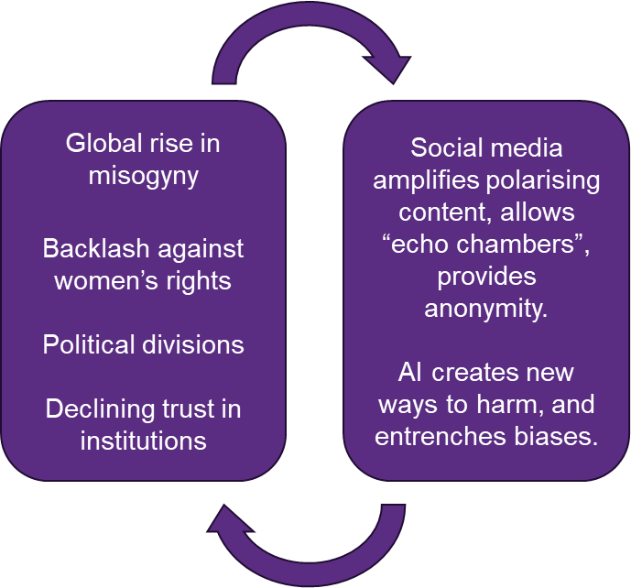

Technology provides opportunities for people to inflict harm by:
- providing new ways to carry out harm, such as deep fakes and doxxing
- providing new channels to contact a victim directly
- making it almost costless to harm someone anonymously (while sending letters and making calls involved significant time and expense, and were easier to trace)
- allowing perpetrators to spread content to a wide audience, or to join forces with others or use “bots” to increase the number of attacks on a victim.

“Then you get these swarms. I put up a post recently … And within a few hours, I had 300, 400 upwards and upwards and upwards comments … [from people with hidden identities and maybe from bots] … So, I don't know if it was bots so much as it was clearly orchestrated, it was ‘right everyone's gonna go and destroy this person today’” - Member of Parliament

Online harm is also hard to address because:
- attacks can be anonymous and hard to trace
- perpetrators can cause harm from a distance, including from other countries with different laws, and outside the reach of our laws
- technology changes faster than legislation.

Growing misogyny drives online harm
Gender stereotypes and misogyny:
- can be used to justify a view that women are unsuitable for leadership
- are closely tied with behaviours to control and punish women who challenge “male dominance”
- often “frames the success of women as harmful for men”
- thrive online, and drive online harm against women leaders which can be used to deter women from online life and leadership roles.

“The generalised content that you probably consume every day just has like an undercurrent of like, misogyny, and if you’re consuming that all the time, it reinforces all those ideas in your head. So, it makes you not want to put yourself out there as much” - Young woman

Growth in online harm against women mirrors growing misogyny
- The 2025 Gender Attitudes Survey found 33% of males aged 18-34 believe that gender equality has gone too far in New Zealand, compared to 15% for females aged 18-34, and 14% for males aged 65+.
- The Global Institute for Women’s Leadership found that almost a quarter of Australian men thought using sexist or misogynistic language online was generally acceptable.
- The Classification Office has observed concerning trends relating to online misogyny since 2020, including the amplification and spread of misogynistic content online and the targeting of women in public and high-profile roles. Misogyny frequently appears in the type of content that is restricted or even banned.
“It’s very sinister… and it’s pushing these narratives on young men that don’t exist in real life. And this goes into offline because they’ve got a community of young men who feel the same way and that narrative has been pushed on them” - Young woman

Who is doing the harming?
Given the anonymous nature of online harm, we do not know enough about who perpetrates online harm and what drives them.
Here is what we do know:
- Online harm against women in leadership can come from friends, colleagues, political opponents or total strangers.
- Some risk factors include “low self-esteem, feelings of shame and inferiority, escalating anger, concerning communications, and interpersonal difficulties.”
New Zealand evidence suggests:
- A small number of people commit a lot of harm. Some evidence suggests small numbers of people are committing a disproportionate amount of online harm. In Netsafe’s 2025 Annual Survey, 10% of respondents admitted to making unwanted digital communications. 80% of those said they sent multiple such communications.
- Men are more likely to commit online harm, but women do it too. In a 2025 study, although women MPs were primarily harassed by young and middle-aged Pākehā men, the abuse from women was often persistent and personal.
- Mental health difficulties may be a driver for some. The same 2025 study found abuse received from individuals with mental health difficulties could be persistent, unpredictable or dangerous. The harassment often subsided when such individuals could access the mental health services and social support they needed. While mental health challenges may be a contributing factor for some perpetrators, this does not imply causation, nor should it detract from accountability for harmful behaviour.
- A link between domestic violence, hostile sexism, and extremist ideologies. While more research is needed to better understand causal connections, online and offline harm to women and girls are linked:
“Online harassment against women and girls is deeply intertwined with offline violence, forming a continuum that includes intimate partner violence, non-partner sexual violence, and online harassment” - Classification Office

Online harm threatens women’s participation
We’ve already seen that women are experiencing more online harm, including threats, which can impact their mental and physical health. It can also require burdensome steps to prevent and respond to.
“A lot of the stuff that’s almost thrown at me online, even on innocuous posts are around my gender, around me being a stupid women, not knowing anything, it’s about my hair colour, my eye colour, my sexuality, it’s about my inability to understand business, and have also been given threats on my life, my family’s life.” – Business leader, life and career coach, author, and creator, Cassie Roma,.
Seeing women being harmed online deters women from continuing or taking on leadership roles and normalises online and offline abuse of women and girls.

It also drives women out of digital spaces, which makes it harder for:
- businesswomen to reach customers
- journalists and influencers to reach an audience
- candidates to be visible to potential voters
- young women to see role models.
“The pressure that if you do fxxk up online, and you have a massive following… even if it’s just like, a thousand people, that’s a thousand people who have seen you. Because like, when’s the last time you’re around a thousand people like all in one space where people were all actually paying attention to you?” – Young woman
The silencing of women’s voices can negatively impact women’s participation in leadership in public life. Over the long term, fewer women in positions of leadership and a lack of diversity in governance normalises women’s exclusion in leadership positions. Online harm is a threat to the representation of women in leadership roles.
“When you see a woman in a leadership role, but you also see the backlash against them, so the vitriol against Jacinda Ardern, that was very off-putting, and I think it can really impact how people see themselves in a role and how they can contribute” - Young woman
In the next section we will discuss:
- what is already being done about online harm
- what research, experts, and young people say needs to change.

What is being done about online harm? Is it enough?
We’ve learned that online harm against women in leadership is increasing because of:
- global trends, including a rise in misogyny
- technology that makes it easier to harm people and harder to regulate that harm.
There is already a range of tools that aim to uphold people’s rights, protect them under law, and support victims of online harm. These include:
- International human rights law and international frameworks
- New Zealand laws
- Strategies and initiatives.
A summary of these is in Appendix Three. They include:
- The Harmful Digital Communications Act 2015, which provides civil remedies and criminal penalties for online harm.
- The Aotearoa New Zealand Code of Practice for Online Safety and Harms, a voluntary code of practice that digital platforms or providers (such as Meta and TikTok) can sign up to.
But many people and organisations think more needs to be done to help to address the problem of online harm and its effect on women in leadership. Here’s what we learned from our research, and from experts and young people.

New Zealand laws and policies may have gaps
The experts we spoke to, along with our research, highlighted some gaps in New Zealand’s policies and laws to address online harm. In summary, we heard that:
- platforms are not taking enough responsibility
- laws have trouble keeping up with technology
- responses focus mainly on harm by and towards individuals
- harm is too narrowly defined.
We are left with a situation where women often experience significant barriers to accessing timely, effective support, particularly where harm falls below legal thresholds or platforms are unresponsive.
The Education and Workforce Committee’s Inquiry into the harm young New Zealanders encounter online, and the roles that Government, business, and society should play in addressing those harms Final Report recommended that Government review the legislative framework for online safety.
Here is more about the gaps and challenges in New Zealand’s response to online harm:

Service providers are less regulated than in many other countries
- The Harmful Digital Communications Act does not require service providers or platforms to report on, or mitigate, risks posed by their services.
- Transparency standards in the Code are lower than in other countries.
- The Code of Practice for Online Safety and Harms is voluntary and emphasises the role of users in managing harmful content, rather than platforms. By contrast, Australia and the United Kingdom both have legally enforceable online safety protections that social media companies must comply with. While user empowerment is necessary, user responsibility is insufficient on its own. Platforms’ actions to manage harmful content could work alongside efforts from governments and communities, such as early intervention with perpetrators, and education on how to avoid, respond to and report harm.
- The Education and Workforce Committee’s Inquiry into the harm young New Zealanders encounter online, and the roles that Government, business, and society should play in addressing those harms Final Report said “we do not consider that online platforms are doing enough to address the gravity of the harm experienced”. The majority of the Committee recommended that the Government establish an independent national regulator for online safety.
Netsafe… is advocating for meaningful change including a review of the Harmful Digital Communications Act to give New Zealanders stronger education, response, recovery and resilience solutions. We’ll keep pressing for law reform combined with changes at global platforms to shoulder more responsibility for harm minimisation, while ensuring civil society has the tools and resources to be the first line of defence.

Law isn’t keeping up with technology
- Existing approaches are largely reactive; it is difficult to future-proof laws for fast-changing technology. For example, in 2024, Netsafe addressed 270 instances of deepfakes – when people used AI to create or modify images, video and audio without the subject’s consent. The Harmful Digital Communications Act does not explicitly cover deepfakes. Netsafe and legal experts want stronger laws and resources to manage this new form of online harm.
- The majority of the Education and Workforce Committee recommended the Government “prohibit the creation and distribution of non-consensual deepfake sexual imagery” and “explore options to regulate deepfake technology”.

Existing approaches take an individualised approach
- The Harmful Digital Communications Act focuses on individual instances of online harm and does not recognise patterns of harm targeting certain groups. Netsafe wants law change to better protect against online hate speech targeted at groups.
- The Harmful Digital Communications Act does not cover coordinated group-based attacks, also known as “mob-style attacks”, a type of online harm often experienced by women leaders.

There is a high threshold for “online harm”
- Under the Harmful Digital Communications Act, Netsafe can investigate and consider individual complaints. Serious cases may be referred to the Police, but there is a high threshold for an offence under the Act, including needing to prove the person intended to cause harm. The intent requirement has been criticised by victims as a loophole for perpetrators.
- The Act defines harm as “serious emotional distress”. This definition does not recognise that multiple, less serious incidents can add up to significant harm. Women leaders often face a constant trickle of harassment rather than singular extreme events.
The responsibility of reporting and managing online harm is often left to the targeted women themselves. A 2023 review of global evidence and implications found “women battle alone, for the most part, to prevent, mitigate, protect, and otherwise address” online harm.
In New Zealand, women leaders experiencing online harm expressed disillusionment with social media companies due to their unresponsiveness to complaints. This lack of response creates an environment of permissibility on social platforms as users see that harassment and abuse is met with no consequences.
“I complained to them for the death threats, but it went nowhere [referring to Facebook]. I never heard from them again…I would have liked to see them take it seriously. They could have banned that person, but they didn't. If a death threat is not serious enough to get banned, what is?”

Online products and services could be designed to minimise harm
Much of the discussion around online harm focuses on how to respond to harm – how to deal with perpetrators and support victims after harm has occurred. But just as the design of online platforms can amplify harm, could they be designed to prevent or minimise it? The Education and Workforce Committee’s Inquiry notes that “there are no obligations on platforms to proactively identify or prevent harmful content”
Safety by Design focuses on how technology companies could design products and services to promote user safety.
The office of Australia’s eSafety Commissioner has worked with industry to develop an approach that:
“encourages technology companies to alter their design ethos from ‘moving fast and breaking things’ or ‘profit at all costs’ to ‘moving thoughtfully’, investing in risk mitigation at the front end and embedding user protections from the get-go.”
Safety by Design promotes three principles:
- Service provider responsibility – users should not bear the full burden of ensuring safety. Rather providers should have processes in place to prevent and address harm.
- User empowerment and autonomy – providers should listen to users, particularly those at greater risk of online harm – and design tools and functions that protect and preserve their dignity and access.
- Transparency and accountability – providers should provide information on, for example, how they are operating according to their safety policies, and how users can address any concerns.
In New Zealand, Safety by Design approaches could strengthen expectations on platforms while retaining flexibility and civil society involvement.

The technology workforce could become more diverse
Online products and services that work better for women, including by using a Safety by Design approach, may happen more smoothly if women were more involved in their design.
According to the 2023 Census, women make up only 29.2% of the Internet Service Providers, Web Search Portals and Data Processing Services industry. This percentage has decreased in recent years. While the industry has grown over that period, the growth in women employed has not kept up.
Census year | Percentage of women employed | Number of women employed
2013 | 36.7 | 1,164
2018 | 33.3 | 1,449
2023 | 29.2 | 1,389
Increasing women’s representation will require dual action: education systems could support more women entering the industry, and platform companies could do more to attract and retain them.
When considering education system responses, it will be important to target the specific qualifications relevant to the ICT workforce rather than science, technology, engineering and mathematics (STEM) in general. In 2024, women made up the majority (59.5%) of STEM graduates of Certificate Level 4 or higher. However, this was largely due to women’s higher representation among Health degree graduates (78.9%).
STEM Subject Graduates, 2024 | Female | Total | % Female
Natural and Physical Sciences | 3,930 | 6,185 | 63.5%
Information Technology | 1,205 | 3,800 | 31.7%
Engineering and Related Technologies | 1,330 | 4,620 | 28.8%
Architecture and Building | 1,165 | 2,710 | 43.0%
Agriculture, Environmental and Related Studies | 975 | 1,625 | 60.0%
Health | 10,855 | 13,765 | 78.9%
Total all STEM subjects | 19,460 | 32,705 | 59.5%

So, there are a lot of potential changes that might helping in preventing and responding to online harm. Taken together, these could reduce the amount and severity of online harm and support women when harm occurs.

Young people want support to become leaders and to prevent and respond to online harm
We also heard from young people about what might prevent online harm, and what might give them the confidence to pursue leadership opportunities.

Young people want support to prevent and respond to online harm
We heard from young people that online harm is affecting their wellbeing. They shared what would help them, including education, strong support networks, and strong processes for reporting online harm:
• Increasing discussions around online harm to raise awareness of what online harm looks like and what contributes to it.
• Introducing media literacy and skills to navigate online content (e.g. critical thinking, fact checking, how to tailor content algorithms) at schools and in spaces that young people frequent such as social media in ways that are accessible and relevant to young people.
“I feel like when I was in intermediate school, I had no idea and believed everything that I saw online. And all I was reading in general as well. I feel like being able to like, talk to younger kids, even though they might not have that sense of cognitive development yet, if you implement it young, they can hopefully like, start developing and remember that.”
• Transparent and accessible processes for reporting harmful online content, with accountability mechanisms to ensure that these reports are being actioned.
“I would feel a lot safer knowing there was a clear pathway to report people who are harmful online and know that they're facing consequences”
• Safe spaces where young people can connect and share their experiences with each other and support each other. These spaces should be facilitated and moderated to ensure the safety of young people.
“Having a community offline and like having those role models and mentors in real life who you can talk to. Having those connections in real life that at least maybe you see once a week and making those bonds in real life definitely makes you feel less alone”

The Education and Workforce Committee’s Inquiry recommended “the Government invest in public online safety campaigns or consider wats to fund… comprehensive resources designed to educate… about online safety”

Young people want more leadership opportunities and role models
We heard from young people that experiencing online harm, and seeing women in leadership being harmed, affects their leadership aspirations.
Experiencing negativity, abuse, and harsh criticism online can be harrowing. Without meaningful support to navigate these experiences, young people can withdraw from online life and become isolated.
They shared what would help them:
• Providing more leadership opportunities for girls and young women that recognise and encourage a broad range of leadership, and the different pathways people may take.
“Sometimes it’s intimidating to see that like, oh this person is in this position of power, and write it off immediately because it’s too intense, but I think you could maybe go like, “Oh they went from being here, to here. Because then you could identify yourself along that trajectory”
• Providing opportunities and workshops for girls and young women to develop and practice leadership skills and build confidence.
“For kids and also for women who are trying to be leaders, just maybe having workshops or something to increase their confidence. Just, giving them spaces to be leaders, like safer spaces, before they take up roles in like a wider society”
• Highlighting and celebrating the achievements of women leaders (e.g. achievements from women in sports, academia, other areas) on social media and public platforms.
“You could also like post on like, social media, like congratulating women in leadership spaces and like making a post where like, “this woman did this, and they’re doing this, and they’re a part of this” and then like, you can do that too”
• Highlighting and celebrating diverse examples of women in leadership (e.g. mothers, sisters, teachers) on social media and public platforms.
“Showing what different kinds of leaders look like, especially at a very young age. So like, all kids can be like, oh that’s someone and they look like me and they sound like me, and they’re a leader too, so I can also be”
• Safe spaces for girls and young women to connect, share experiences, and support each other on their leadership journeys, as well as learn with each other, and inviting past and present women leaders to share their experiences and connect with upcoming leaders in these spaces.
"Creating like, a space, where boys and girls can be really honest with each other and talk about why they think these things and then educating that, would, I think, make spaces so much more comfortable for everyone”

Women can be free to lead – but it won’t happen by accident
We’ve learned that online harm is a big and growing problem in New Zealand and overseas. This increase in harm is driven by trends like growing misogyny, and by tools that make it easier for perpetrators to cause harm without facing consequences.
Women in leadership experience more, and scarier, online harm.
Young women and girls both experience online harm and see it happening to high-profile women. This is affecting their aspirations.
There is a risk that more women leaders will retreat from public life, and that young women won’t feel safe and confident to fill their shoes.
Over time, we may have fewer women in positions of power. With fewer women at decision-making tables, women’s rights, or position in the economy and society could go backwards.
“Women have fought so long… to like, gain positions of power, and for like, social media and the online world to just like, deteriorate that… It’s just like so disempowering as well to… become a leader and like stand forward for what’s right.” – Young woman
We’ve heard that the tools to combat online harm could be strengthened by:
- making platforms report on and mitigate risks posed by their services
- future-proofing laws for changing technologies and novel forms of harm.
And that companies could prevent harm by:
- designing their products and services with safety at the forefront
- listening to users who have experienced, or are at greater risk of online harm
- recruiting more women.
And we’ve heard that young people want:
- better education and support to prevent online harm, and to cope with it when it occurs
- role models that show them a pathway to leadership, and opportunities to develop their skills and confidence.
If we take action to address online harm, we can hope for a bright future for women in leadership.
"Leadership is like, not just creating a path, but also the people you make it with" – Young woman

Appendix One:

Survey respondents
The Ministry conducted an online survey from 20 November 2024 to 20 December 2024 and received 53 responses. The survey comprised a set of close ended and open-ended questions on the causes, consequences and long-term trends of online harm. Of the 53 respondents:
- 94% identified as a woman and 4% as a man and 2% preferred not to say.
- 58% identified as Pakeha, 23% identified as Māori and 4% identified as Pacific.
- 42% identified as being in a leadership or public facing role.
- Most were aged 35-54 (31% were in the 35-44 age bracket, and 25% were in the 45-54 age bracket).

Non-governmental organisations and groups, and government agencies
The Ministry also talked with community organisations, government agencies women’s networks, independent agencies and research groups, including:
- Centre for Asian and Ethnic Minority Health Research and Evaluation (CAHRE)
- Christchurch Call
- Classification Office
- Disabled People’s Organisations Coalition (DPO)
- e-Safety Commissioner’s office (Australia)
- Government Women’s Network
- Human Rights Commission
- InsideOUT New Zealand
- Local Government New Zealand
- Māori Women’s Development Inc
- Massey Marsden Group
- Ministry of Foreign Affairs and Trade
- Ministry of Justice
- National Council of Women of NZ
- Netsafe
- Philanthropy NZ
- Vine (Violence Information Aotearoa), previously the New Zealand Family Violence Clearinghouse (NZFVCH)

Youth engagements
The Ministry worked with Koi Tū Centre for Informed Futures to hold workshops to explore young people’s perspectives on online harm and the future of leadership. Participants were mostly young women and girls, aged 16-25, though some people identifying as other genders attended. Workshops were held through the following groups or organisations:
- All is for All (disabled youth)
- Islamic Women’s Council of New Zealand
- Queen Margaret College
- Whangarei Girls High School
- Classification Office Youth Advisory Panel

Appendix Two: Examples of online harm women in leadership experience.
Types of Online Harm | Definition | What this can look like for women in leadership
Image-based abuse | Sharing or threatening to share private or intimate images/video, including deepfakes (highly convincing fake images, video or audio created using Artificial Intelligence).  Sending unwanted images or sexually explicit content such as unsolicited sexual images and broadcasting sexual violence images. | Image-based sexual harassment, often including misogynistic narratives, falsely accusing women of professional misconduct, spreading smears to damage their reputations, and using malicious misrepresentations like 'deepfake' porn videos, abusive memes, and manipulated images.
Harassment and abuse | Encompasses a variety of unwanted digital communication, which can range from a single incident or comment, to coordinated, long-lasting attacks. Digital harassment against women and girls can consist of a range of messages and communication and is often gendered or sexualised in nature.
Doxing | Sharing personal information without consent, such as a person’s address, to expose them to further harassment and violence. | This can make victims reluctant to freely express their opinions.  It can lead to stalking, threats, and even physical violence.
Threats of violence | A range of threats of violence (including rape and death threats) posted online and/or received through personal messages on social media
Gendered hate speech | Communication that seeks to degrade another based on their identity or stereotypical characteristics. Gendered hate speech specifically targets women, girls and LGBTQIA+ people. It can include threats and incitements of violence and can lead to offline violence. | Research from the Hate and Extremism Insights Aotearoa’s categorised 8.5% of all hate speech in New Zealand over a 4-month period as misogynistic. Online hate speech was categorised as misogynistic when it described the “vilification, abuse, and/or dehumanisation of women”
Gendered disinformation | The intentional use of false or misleading gender and sex-based narratives against a person on the basis of their gender, aimed at discrediting and/or keeping them from participating in the public sphere and to promote political, economic, or social objectives. | Online gendered disinformation targeting women in public life. This can include orchestrated disinformation campaigns designed to undermine the credibility of women in public leadership roles.  A global study interviewing over 100 women political leaders found many of them were “targeted through gendered disinformation campaigns, building on gender biases, deployed in a coordinated manner and designed to undermine them and their civic or political agendas.”
Cyberstalking | Stalking is characterised by a perpetrator making unwanted, persistent and repetitive intrusions into another person’s life, causing a range of serious emotional, psychological, social and economic harm to that person. Stalking increasingly makes use of digital technology and the internet (cyberstalking) | Cyberstalking is a worldwide phenomenon which accelerated with the rise of the internet and was exacerbated by the COVID-19 pandemic. Cyberstalking behaviours have increased against New Zealand Members of Parliament. This includes inappropriate social media contact or emails, distribution of malicious material and threats to harm.
Trolling | Trolling is posting provocative content to upset others or disrupt conversations. It happens on social media, gaming platforms, and forums. Trolls often stay anonymous to avoid consequences.  This includes behaviours like repeatedly commenting to provoke or mock someone, often to get a reaction. Trolls often post under a fake name or anonymously, so they can say things without being held responsible.

Appendix Three: Existing approaches to addressing online harm
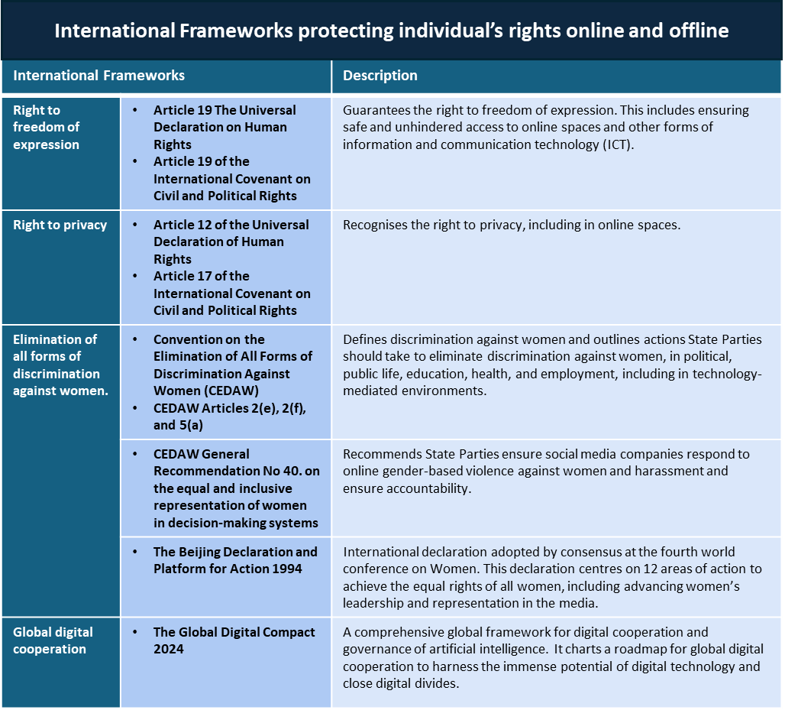

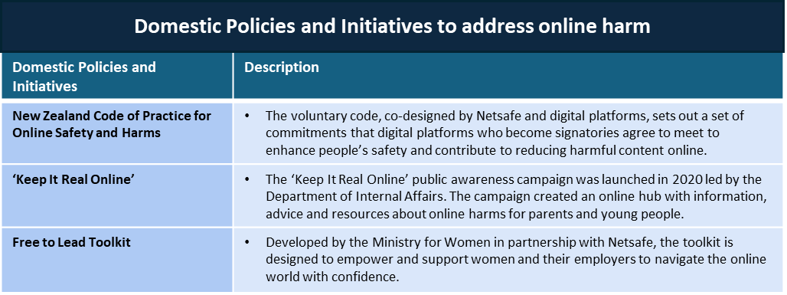

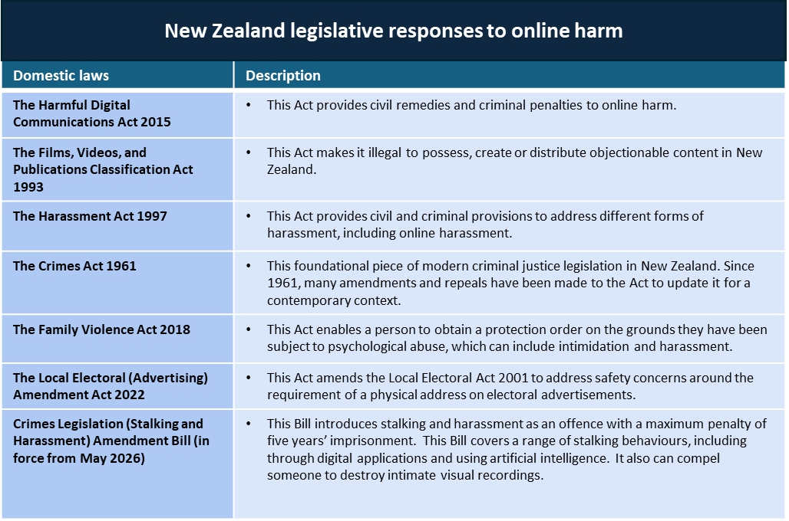

Endnotes

Netsafe is an independent, non-profit online safety organisation, with two distinct roles relevant to online harm: 1. its Statutory role as the Approved Agency to receive, assess and investigate complaints, to use advice, negotiation, mediation, and persuasion to resolve complaints under New Zealand's Harmful Digital Communications Act and 2. its advocacy and advisory role, as a charity providing online safety support, expertise and education to people in Aotearoa New Zealand.
Bots are software programmes that can be used to mimic humans on social media. It can be hard to tell if comments or messages are from a real person or a bot.
Rangihau Aotearoa (2025). Aotearoa New Zealand Gender Attitudes Survey 2025 https://genderequal.nz/wp-content/uploads/2025/09/NCWNZ_Gender-Attitudes-2025.pdf
Suzie Dunn, Tracy Vaillancourt & Heather Brittain (2023). Supporting Safer Digital Spaces Special Report. Centre for International Governance Innovation https://www.cigionline.org/documents/2314/SaferInternet_Special_Report.pdf https://www.cigionline.org/publications/supporting-safer-digital-spaces/
Netsafe (2025) Netsafe 2025 Annual Survey Online Hate Speech Report Netsafe-2025-APS-report-Online-hate-speech-5-Aug-25.pdf
InternetNZ (2024). New Zealand’s Internet Insights: 2024 Survey findings. https://internetnz.nz/assets/Archives/New-Zealands-Internet-Insights-2024.pdf
Pew Research Center (2021). The State of Online Harassment. https://www.pewresearch.org/wp-content/uploads/sites/20/2021/01/PI_2021.01.13_Online-Harassment_FINAL-1.pdf
Dunn et al (2023)
The Economist Intelligence Unit (2021). Measuring the prevalence of online violence against women. https://onlineviolencewomen.eiu.com/
Inter-Parliamentary Union (2018) Sexism, Harassment and Violence against Women in Parliaments in Europe. https://www.ipu.org/file/5472/download
Plan International (2020). Free to Be Online? Girls’ and Young Women’s Experiences of Online Harassment. https://plan-international.org/uploads/2023/06/SOTWGR2020-CommsReport-edition2023-EN.pdf.
Ministry for Women, Netsafe (2018). New Zealand Teens and Digital Harm. https://www.women.govt.nz/sites/default/files/2021-08/NZ-teens-and-digital-harm_statistical-insights_2018%20%281%29.pdf
International Center for Journalists (2022). The Chilling: A global study of online violence against women journalists. ICFJ Unesco_TheChilling_OnlineViolence.pdf
Inter-Parliamentary Union (2025). Sexism, Harassment and Violence against Women in Parliaments in the Asia-Pacific Region. https://www.ipu.org/file/21204/download
Susanna Every-Palmer, Oliver Hansby, Justin Barry-Walsh (2024), "Stalking, Harassment, Gendered Abuse, and Violence towards Politicians in the COVID-19 Pandemic and Recovery Era". Frontiers in Psychiatry. https://pmc.ncbi.nlm.nih.gov/articles/PMC11060435/
Watson, R., Hammans, L., Hansby, O., Barry-Walsh, J., & Every-Palmer, S. (2025). Misogyny, racism, and threats to our families: a qualitative study of harassment of female politicians. Kōtuitui: New Zealand Journal of Social Sciences Online, 20(4), 979–1007. https://doi.org/10.1080/1177083X.2025.2473949
Ibid
Disinformation Project (2023). Race and Rage: Examining Rising Anti-Māori Racism and White Supremacist Ideologies in Aotearoa New Zealand. https://www.thedisinfoproject.org/s/Race-and-rage-Examining-rising-anti-Maori-racism-and-white-supremacist-ideologies-in-Aotearoa-New-Ze.pdf
Te Mana Whakaatu Classification Office. (2024). Online misogyny and violent extremism: Understanding the landscape (Summary Report). https://www.classificationoffice.govt.nz/documents/238/20240513_Online_Misogyny_and_Violent_Extremism_understanding_the_landscape_sum_hbk6q0J.pdf
Watson et al (2025)
OECD (2021), Man Enough? Measuring Masculine Norms to Promote Women’s Empowerment. Social Institutions and Gender Index, OECD Publishing, Paris, https://doi.org/10.1787/6ffd1936-en
Watson et al (2025)
Eva Corlett (2022). “Here be trolls: New Zealand’s female politicians battle rising tide of misogyny” The Guardian 8 April 2022 https://www.theguardian.com/world/2022/apr/09/here-be-trolls-new-zealands-female-politicians-battle-rising-tide-of-misogyny
Jenni Long (2024). The Relationship Between Misogyny, Anti-LGBT+ Hate Speech and harmful inaccurate information in Aotearoa. Hate & Extremism Insights Aotearoa, p. 24
Fontanella, L., Chulvi, B., Ignazzi, E. et al (2024). How do we study misogyny in the digital age? A systematic literature review using a computational linguistic approach. Humanit Soc Sci Commun 11, 478 (2024). https://doi.org/10.1057/s41599-024-02978-7
Watson et al (2025)
Suzie Dunn (2020). Technology-Facilitated Gender-Based Violence: An Overview. Centre for International Governance Innovation. https://www.cigionline.org/documents/1784/SaferInternet_Paper_no_1_coverupdate.pdf
Inter-Parliamentary Union (2025)
Rangihau Aotearoa (2025). Aotearoa New Zealand Gender Attitudes Survey 2025
The Global Institute for Women’s Leadership (2022) International Women’s Day 2022. International Women's Day 2022
Te Mana Whakaatu | Classification Office. (2024). Online Misogyny and Violent Extremism: Understanding the Landscape (Summary report).
Social Development Direct (2023). Technology Facilitated Gender Based Violence: Preliminary Landscape Analysis. Technology-Facilitated Gender-Based Violence: Preliminary Landscape Analysis
Shannon Zhan (2024). From Harassment to Harm: Understanding and Combatting Gender-Based Violence in New Zealand. from-harm-to-harassment-understanding-and-combatting-online-gender-based-violence.pdf
Netsafe (2025). Annual Survey 2025 Report. 2025-Netsafe-APS-report-8-Aug---New-branding.pdf
Watson et al (2025)
Watson et al (2025)
Te Mana Whakaatu | Classification Office. (2024). Online Misogyny and Violent Extremism: Understanding the Landscape (Summary report).
New Zealand House of Representatives Education and Workforce Committee (2026). Inquiry into the harm young New Zealanders encounter online, and the roles that Government, business, and society should play in addressing those harms. https://selectcommittees.parliament.nz/view/SelectCommitteeReport/8ea2b219-7275-46a3-078e-08de377b9ec7
The Code: Aotearoa New Zealand Code of Practice for Online Safety and Harms (2022) https://thecode.org.nz/wp-content/uploads/sites/38/2023/06/THE-CODE-DOCUMENT-FINAL.pdf
New Zealand House of Representatives Education and Workforce Committee (2026).
Netsafe (2025) Year in Review Juny 2024-June 2025. https://resource.netsafe.org.nz/Netsafe-2025-Annual-Review.pdf
Zhan (2024)
Jankowicz et al. (2021). Malign Creativity: How Gender, Sex, and Lies Are Weaponised against Women Online. www.wilsoncenter.org/publication/malign-creativity-how-gender-sex-and-lies-are-weaponized-against-women-online
IREX (2023), Technology-Facilitated Gender-Based Violence as an Attack on Women’s Public Participation: Review of Global Evidence and Implication. Note the full report is no longer available online. The summary report is here: https://www.irex.org/files/global-tfgbv-evidence-two-pager.pdf
Zhan (2024)
Zhan (2024)
New Zealand House of Representatives Education and Workforce Committee (2026).
Australian Government eSafety Commissioner: https://www.esafety.gov.au/industry/safety-by-design
New Zealand House of Representatives Education and Workforce Committee (2026).
Jenni Long (2024)
Sara Bundtzen (2023). Misogynistic Pathways to Radicalisation: Recommended Measures for Platforms to Assess and Mitigate Online Gender-Based Violence. Institute for Strategic Dialogue https://www.isdglobal.org/wp-content/uploads/2023/09/Misogynistic-Pathways-to-Radicalisation-Recommended-Measures-for-Platforms-to-Assess-and-Mitigate-Online-Gender-Based-Violence.pdf
Lucina Di Meco (2023). Monetizing Misogyny: Gendered Disinformation and the Undermining of Women’s Rights and Democracy Globally. https://she-persisted.org/wp-content/uploads/2023/02/ShePersisted_MonetizingMisogyny.pdf
Ministry of Justice (2024). Regulatory Impact Statement: Establishing an Offence of Stalking. https://www.justice.govt.nz/assets/Documents/Publications/RIA-Establishing-an-Offence-of-Stalking.pdf
Ibid.
Australian Government eSafety Commissioner: www.esafety.gov.au/young-people/trolling
Manatū Wahine Ministry for Women. Free to lead: Backing yourself to engage online with confidence https://www.women.govt.nz/courses/individuals/#/lessons/lxtz0pr4TaocWPhrTP30xqb6jhdChKlg

