

Taitara | Procurement Policy

Version | V.5 | Contact | Organisational Performance and Services
Policy Owner | Deputy Secretary - Organisational Performance and Services | Approved | May 2026
SharePoint | Internal Policies | Due for Revision | May 2027

Introduction
Expenditure of public money carries responsibilities for good judgement, prudence, and strong controls to ensure it can withstand parliamentary and public scrutiny. This maintains trust and confidence in the public sector. Procurement must reflect responsible expenditure of public funds and the principles of public value as defined by the Government Procurement Rules (5th Edition, 2025).
Procurement covers all the business processes associated with purchasing the products and services we use to run our business and deliver our public service objectives. It starts with identifying our needs, then planning the best way to meet them; continues through sourcing the goods/services/works then managing the contract; and ends with expiry of either the contract or the useful life of the asset.
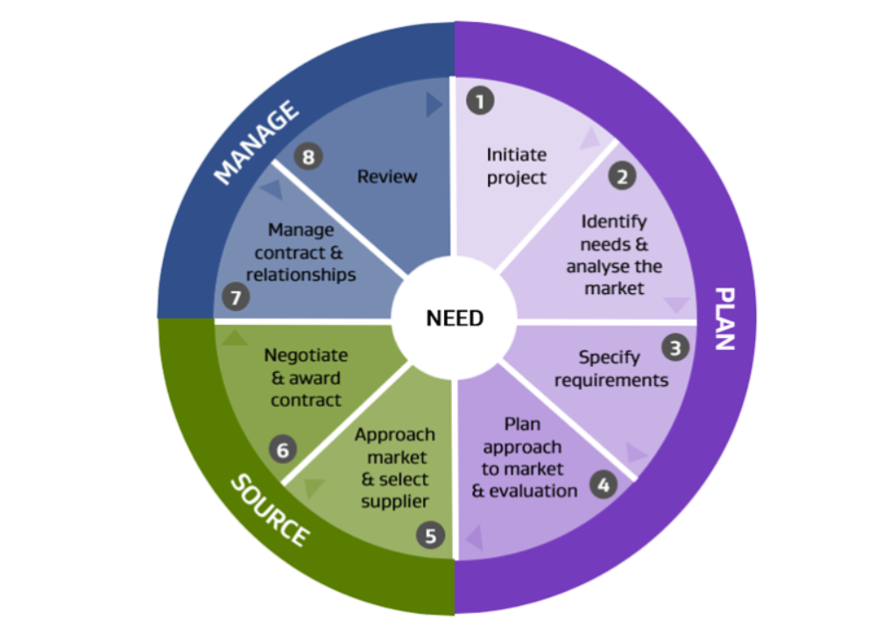
The Ministry is the government’s principal advisor on achieving better outcomes for women. Our procurement supports this role by ensuring that we purchase products and services in an efficient and cost-effective manner, maximising our resources available to influence positive change for New Zealand women.

Compliance with the Government Procurement System

The Ministry for Women recognises the role of the Procurement System Leader and the broader government procurement system in setting expectations for good procurement practice.

All procurement activity must comply with:
- The Government Procurement Rules (5th Edition and any subsequent updates)
- Associated government directives, policies, and guidance issued from time to time
- This Procurement Policy and supporting guidelines using referenced templates

Non-compliance with this Policy or the Government Procurement Rules must be identified, recorded, and addressed. Systemic or material non-compliance may be escalated through governance channels and may result in corrective actions, additional assurance activity, or reporting obligations.

Kaupapa | Purpose
This policy and the associated procurement guidelines outline the approach that the Ministry will take to planning, sourcing and managing its procurement.

Hōkaitanga | Scope
This policy applies to all Ministry for Women staff, consultants and contractors.
This policy does not apply to the procurement of:
- Permanent or fixed term employees (note that recruitment services are included in this policy)
- Disposals or sales by tender
- Investments, loans, and guarantees
- Travel and sensitive expenditure such as gifts, donations, sponsorships, ex-gratia payments, koha and unconditional grants. These types of expenditure are covered by their own policies.
- Core Crown legal matters
- Public prosecutions
- Goods, services or refurbishment works that are purchased for commercial resale.

Ngā Mātāpono | Principles
The government procurement framework requires a focus on achieving public value while supporting the delivery of better public services. Procurement activities should be conducted to:
- Deliver economic benefits to New Zealand
- Look for new and innovative solutions
- Engage with businesses with responsible business practices
- Promote inclusive economic development within New Zealand
- Manage risk appropriately
- Encourage collaboration for collective impact
The Ministry aligns with the Government Procurement Principles:
- Plan and manage for great results
- Be proportionate and right-size the procurement
- Be fair to all suppliers
- Get the right supplier
- Get the best deal for everyone
- Play by the rules

Ngā Painga Ōhanga ki Aotearoa | Economic Benefits to New Zealand
For products and services procured with an estimated whole-of-life value of $100,000 or more (excluding GST), the organisation must seek economic benefits to New Zealand in accordance with the Government Procurement Rules. Economic benefits must be proportionate to the size, scope, and risk of the procurement. This includes:
- Identifying and clearly articulating the economic benefits sought as part of the procurement planning process;
- Including economic benefit as a weighted evaluation criterion, with a minimum weighting of 10% of the total evaluation score, unless an explicit and documented exception is approved;
- Incorporating agreed economic benefit commitments into the contract; and
- Monitoring and managing delivery of those commitments over the life of the contract.

Ngākau tapatahi me Whaiwhakaaro | Transparency and Accountability
All procurement activity must be conducted in a manner that supports transparency, integrity, and accountability for the use of public funds. This includes requirements to:
- Maintain clear and complete procurement records that demonstrate compliance with this Policy and the Government Procurement Rules;
- Document key decisions, including sourcing method, supplier selection, evaluation outcomes, and approval of any exceptions or exemptions;
- Consider any interests that may arise and consult the Conflict of Interest policy.
- Publish contract award information where required by the Government Procurement Rules or applicable government guidance; and
- Provide procurement information and reporting as required to support system-level transparency and oversight.

Ngā Tūmahi me ngā Haepapatanga | Roles and Responsibilities

Management
The Leadership Team is responsible for ensuring that all staff, consultants and contractors are aware of the policy and that it is followed.

Deputy Secretary - Organisational Performance and Services
Deputy Secretary Organisational Performance and Services is responsible for reviewing the policy once a year with interim revisions as required to meet operational and organisational needs.
In general, the Ministry uses collaborative contracts negotiated for the whole of NZ government and approved government model templates as our default tender and contract documents. Where a particular procurement activity is considered too high value or too complex to use the model templates, the Deputy Secretary - Organisational Performance and Services will engage legal assistance to assist in the drafting and approving of the contract, in line with the procurement guidelines.
The Deputy Secretary - Organisational Performance and Services is also responsible for providing guidance on interpretation of this policy.

All Staff
All staff, consultants and contractors are responsible for applying this procurement policy and for following the procurement guidelines.

Procedures
We will apply the Government procurement framework when planning, sourcing and managing our procurement, as this sets the standard for good practice (including financial thresholds and procedures for advertising procurement opportunities).
The way we buy products and services will vary depending on the value, complexity and risk involved. We will apply the approach best-suited to the individual purchase, within the framework.

We will consider if the need can be met via existing collaborative contracts such as an All of Government (AoG), Syndicated, or a Common Capability contract. Where suppliers have been selected to form a panel, this is known as secondary procurement.

Below-Threshold Procurement
While certain mandatory requirements of the Government Procurement Rules apply only to procurements at or above prescribed value thresholds, best practice expectations apply to all procurement activity, regardless of value.
For procurement with an estimated value below $100,000, procurement decisions must:
- Be fair, transparent, and proportionate to the value and risk of the procurement;
- Where appropriate, support capable New Zealand businesses and suppliers; and
- Be supported by documented rationale, particularly where established best practice is not followed.
Procurement staff must be able to demonstrate how below-threshold procurements achieve value for money and align with the intent of this Policy.

Preparation
When preparing procurement activities, we will:
- First review the procurement policy and guidelines
- Consider, document and, if necessary, agree a management plan for any actual, perceived or potential conflicts of interest
- Ensure we have financial approval aligned with the Ministry’s financial delegation policy before going to market
- Consult collaborative contracts, to leverage New Zealand Government’s collective bargaining power and templates.
- For templates used in the process, see the Procurement Guidelines.

koha - Te Aka Māori Dictionary
Secondary procurement means procurement where groups of suppliers have been pre-qualified to supply products and services and can be used without new qualification activities for procurement, as opposed to primary or direct source (traditional customer and supplier) procurement.

